Highway Road repairs
There are many types of road maintenance and reconstruction. From simple pothole filling to full depth reclamation each process addresses specific problems with the surface and sub-surface of the roads we all travel on. This article is designed to give general information on the 6 different methods we use to correct or repair the roads in East Bridgewater. Three methods are considered to be maintenance oriented and three methods deal with reconstruction. We will first talk about the maintenance side of things.
The first, most simple, quickest and cheapest method to repairing and maintaining our roads is filling potholes. Generally done once a month in good weather, a crew of 3 to 5 DPW employees pick up between 1 and 4 tons of "hot mix"asphalt. This asphalt comes directly from state approved asphalt processing plants and is dumped into our enclosed trailer that is equipped with a burner system that keeps the asphalt hot and workable. One employee goes and picks up the asphalt from the plant then joins the crew and they start to fill the potholes on the list. A pothole is correctly filled by cleaning out any loose, sandy material from the hole, and then filling the hole, using a shovel, with hot mix to between a half and an inch and a half above the top of the hole. The next step is to compact the hole using a tamper or vibratory compactor depending on the size of the hole. Finally more hot mix is added to flush the new asphalt patch with the existing road and that gets tamped again.
We usually wait to do potholes until a substantial list of potholes accumulate because it is more cost effective. Pothole patching is usually the first step in maintaining the road. All pothole work is done by DPW employees. You can see typical pothole patches on some roads in town like Washington st and most subdivisions
The second method is called crack sealing. Crack sealing is done by outside contractors and usually on one particular street in advance of micro-paving (which we will talk about next). Crack sealing involves a crew of 5 or 6 contractor employees. The first step is to blow out the cracks in the road with an air blower or compressor. The next step is to apply a mixture of items that may include liquid asphalt, rubber, emulsion, fibre or selant. This mixture is very hot and fills the crack top to bottom and side to side. The type of ingredients depend on the road condition, size and length of the crack, and preference. The final step is to apply a product called Black Beauty. The Black Beauty gets applied to the crack sealant to prevent the crack sealant from sticking to the tires of the vehicle. Crack sealing prevents water from getting into the road surface causing problems like rutting or potholes.
The next method is called micro-paving. "Micro" involves laying down a thin wearing course of road surface to prolong the life of the existing road. It is very similar to sealing your driveway but in a more industrialized application. Micro-paving requires crack sealing to be done first. Then the road is blown off to remove dirt, sand and debris. Next a tank truck applies a tack coat.
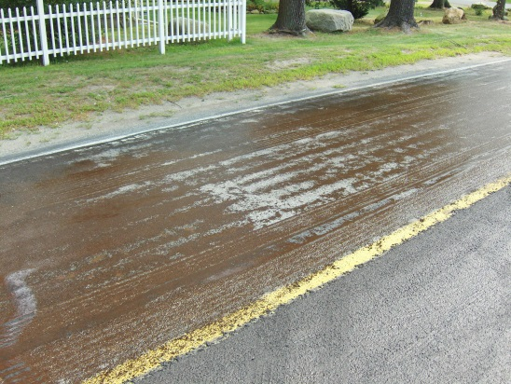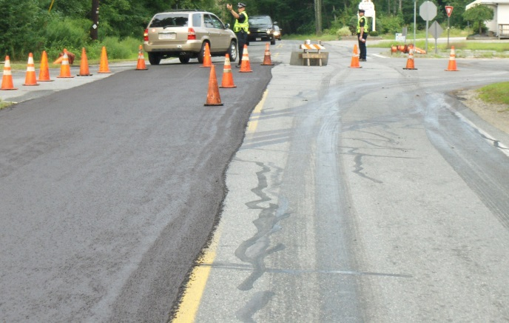
Tack is a very sticky substance that adheres the micro to the existing road. After the tack coat is applied a special machine lays down an 1/8" layer of micro-pavement. The micro-pavement consists of Liquid asphalt, stone dust, water and portland cement.
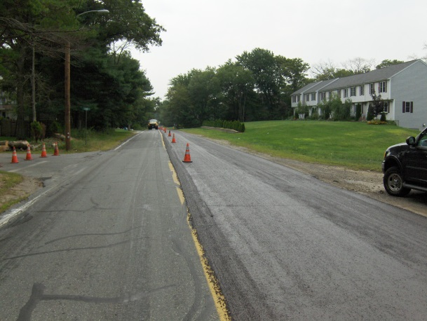
It takes approximately 20 minutes to a half hour to dry during which vehicle traffic is not allowed. In most micro-pavng applications 2- 1/8" lifts are used for a total of 1/4" layer of new wearing course.
Micro-paving cannot be used on all roads. The road must still have its shape and there cannot be major ripples, potholes or uneven pavement. If a road condition shows one of the factors above it is beyond the point of micro-paving.
Cold planing or milling is a method of reconstruction used when the surface of the road is deteriorated but the road base is still strong. You can tell when a road is a good candidate fior cold-planing when you see very shallow potholes sometimes called scabs. What this means is that the top layer of asphalt has cracked and broken and is no longer attached to the base course of asphalt. Cold-planing/Milling involves a machine that grinds or chews off this top layer of asphalt and leaves a rippled surface for the new surface to adhere to. After milling a new layer of asphalt is put down to replace the amount that was ground up. Most milling jobs only grind off between 1 and 2 inches of existing asphalt. Milling a road is somewhat cost effective because the material collected during the process can be re-used for other projects. All milling of roads and the subsequent new asphalt layer is accomplished by outside contractors.
An intermediate method of improving road "ride-ability" is called overlaying. Overlaying is done by outside contractors and is faster that cold-planing. Overlaying is simply putting a new course of asphalt over the existing road. Sometimes a leveling course is put down to fill in deep ruts and holes before the final wearing surface is applied. Overlaying is useful on roads that are main roads that do not receive a lot of regular traffic. It is a cheaper alternative to milling or reclamation and still has some structural benefits.
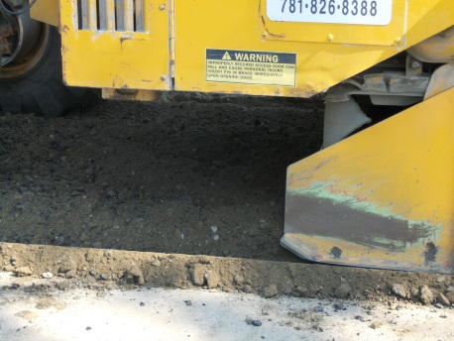
The final method of road construction or rehabilitation is called reclaimation. This process involves a large machine that chews up the existing .
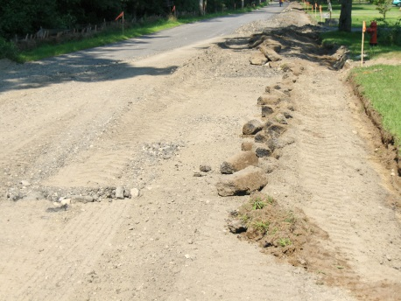
pavement and mixes it in with the soil below to create a stronger base for the new asphalt to be placed on. Reclamation takes longer because the road surface has to be graded after the chewing process to ensure proper drainage and profile when the road is re-paved. After the grading is done and the road is completely compacted, a base course of asphalt is put down at a thickness of 2-4" depending on the amount of traffic the road normally takes. After the base course is put down a top course or "wearing" course is applied. This wearing course is 1 1/2 to 2" thick.
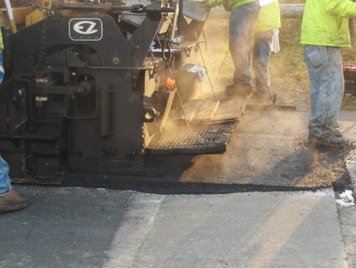
We usually use the reclamation method when the road surface and its base has deteriorated so far that there is obvious rutting, potholes, large wide cracks and heaves.
These are the methods that the DPW in East Bridgewater uses to repair and improve the roads in town. The type of repair used depends on a number of factors. Cost, physical condition of the road, traffic volume, future projects and future development are some of the factors that we weigh when deciding which roads to work on and which method to use on any particular road. We have recently incorporated a pavement management system that uses a computer program to weigh all the factors mentioned above and then makes recommendations for road work to be done in a consecutive three year period. For more information on any of these methods you can call the DPW office.

