FAQ- Highway and Land Management Division
Q. If I notice a pothole should I call the DPW?
A. Yes, residents are often a good source for us to find out about potholes.
Q. What happens when I call in a pothole?
A. It is put onto a list, and is done usually the next time we get hot mix. In good weather we are filling pot holes once a week.
Q. Who do I call if I notice that a streetlight is out?
A. Call Board of Selectmen’s Office @ 508-378-1601
Q. Who do I call if I see a sign is down or missing?
A. Call DPW to report at 508-378-1620 or click on the Report a Problem link on the website
Q. What if I notice that a tree near the street in front of my home appears to be dead or dying?
A. Report this to DPW. A representative will come out and determine first, as to whether or not it is a town tree, and second, the extent of work necessary.
Q. What about trees along Route 18?
A. Massachusetts Highway Department takes care of these trees. Report it to them @ 1-800-635-3590.
Q. What if I see a dead animal on the road?
A. Call Police Dept @ 508-378-7223. They have direct radio contact with the Animal Control Officer.
Q. Is it alright to place a basketball hoop on the street or on sidewalk?
A. No, there is a by-law which prohibits this.
Q. If I need to pump water out of my home, where am I allowed to discharge this water?
A. Into your backyard only. It is prohibited from being discharged into street by a Town by-law.
Q. Can I prune or remove a town tree in front of my house?
A. In most cases no. Any town tree that a resident has an issue with must be maintained or removed by the town. The DPW is reluctant to remove healthy trees unless it causes a serious potential threat to a resident.
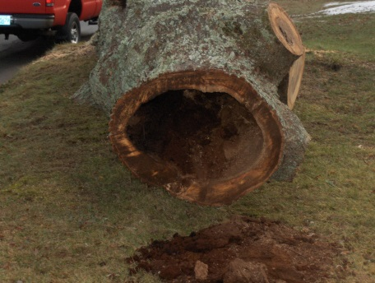
Q. There is a tree at my home or business that blocks my view when I try to exit onto the road, can it be removed?A. As stated above, the DPW is very reluctant to remove healthy trees. The DPW is investigating a program where the tree in question would be removed and the resident or business would voluntarily donate funds or replacement trees for the town to plant. More information will be available in the near future.
Q. How do I get wood chips or firewood from town trees that have been removed?
A. You may request wood chips by calling the DPW office or by requesting a delivery on the website. The woodchips we offer are not clean and will have some small sticks in them. We will make every effort to deliver the chips where you want them however we will not return and remove the chips for any reason. Firewood may also be requested be calling the office or on the website. The firewood may be any size, length or type (maple, oak, elm etc.). In many cases the resident who lives at the house where the tree was removed gets the right of first refusal.
Q. I have rain water running off of the street onto my property, what can be done?
A. In most cases the DPW can install an asphalt berm. The berm will stop and re-direct any water coming from the road. There are some issues to consider when a berm is installed. Contact the DPW for more information.
Q. Does the DPW pick up litter on the side of the road?A. The DPW does pick up litter. We typically only do it once or twice a year. Residents are encouraged to pick up roadside trash and the DPW will provide trash bags and collect the trash once it is bagged. Please call the office for more information.

